


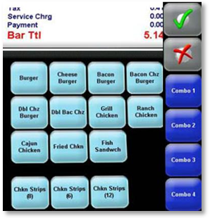
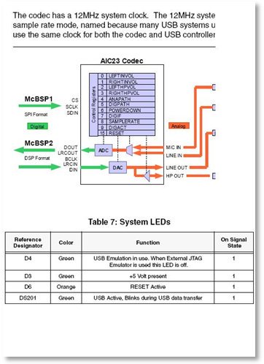
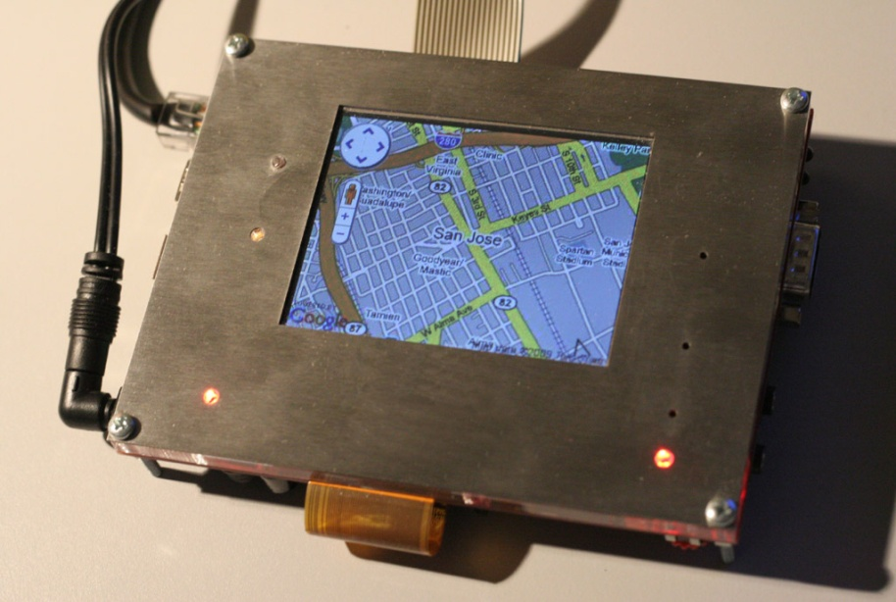
On line help - Provide content rich, dynamic on line help.
Point Of Sale - Use web authoring techniques to create screens for portable and fixed POS terminals.
The EBS JavaScript Embedded Toolkit (JET) is a powerful tool for developing embedded Graphical User Interface applications. The underlying rendering engine utilizes Dynamic HTML, Cascading Style Sheets, and JavaScript allowing user interfaces to be designed using standard Web authoring tools. JET is built on webC technology that has been in the marketplace for 10 years.
The toolkit runs on 32 bit processors in a small footprint and minimal memory usage. It can be deployed on top of an embedded operating system, or without one altogether. Similarly, JET supports several industry graphics packages, but will also run independent of a graphics package using its own native frame buffer driver.
Royalty free licensing and full source code access, makes integration seamless.
Create graphically rich intuitive and responsive user interfaces for your embedded application in less time, with less effort and with a better look and feel.
JavaScript Embedded Toolkit
JET enables rapid and robust application development, whether it’s simple dialog building, rich content, freeform graphics, or integration with the Web sites. Dialogs can be built using HTML forms including graphical elements. The HTML rendering engine is a natural fit for rich content applications like help systems.
Freeform graphics capabilities are provided to JavaScript application software through a set of proprietary DOM extensions. These allow the application code to render graphic elements at run-time.
Because the underlying rendering engine uses standard DHTML and JavaScript, integration with Web sites is trivial.
Application scripts are extensible through “C” language hooks. This allows integration with application specific hardware and software.
Developing consumer devices with client side user interface and internet browsing capability.

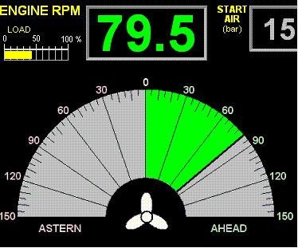
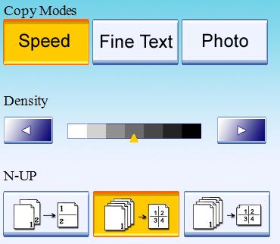
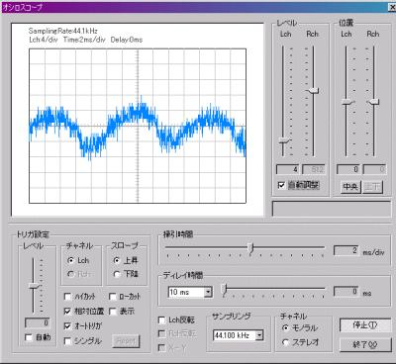
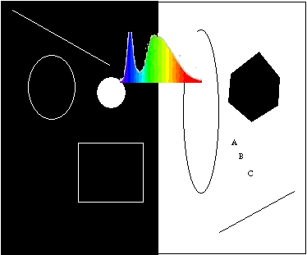

Industrial - Connects a JavaScript, image based UI to your C based Real Time environment.
Business Machines - Create rich user interfaces with image, language and style localization.
Real Time - Create a rich UI with JavaScript and combine JET C based graphics primitives.
Mix standard JavaScript and HTML with JET JavaScript extensions and your own application specific 'C' source code to develop powerful applications in less time.
Develop graphical user interfaces for a wide range of industries and applications.
The JavaScript Embedded Toolkit offers ease-of-use unparalleled by other GUI development platforms. Applications can be written with easy to use, off-the-shelf Web development tools.
- Basic controls can be created and positioned dynamically or they can be included in source html documents that act like resource files. Style Sheets and background add extra decorations.
- JavaScript event and programming model for easy and rich UI.
- Use clip art, custom artwork and photographic images to create custom buttons, keypads, slide pots, dials, thumb-wheels.
- Easy JavaScript programming model.
- Powerful results, execute in 'C' if you need to.
- Text boxes in one line of code and images backdrops.
- Use JET Framework to call native 'C' executable code and pass parameters.
- Combine background images, active screen areas, active DOM objects, fast image manipulation.
- Use flexible compact standard JavaScript programming to develop your embedded application's user interface needs.
Native performance, polygon, line, arc and ellipse draws. Bitmap images are the canvas so any graphic element may be custom dawn. Alpha channel support for creating high performance image overlays. Bitmap transformation functions for blending, and sprite graphics.
Building instrumentation requiring both a rich user interface and high performance native graphics. JET provides a gateway between JavaScript and C to run signal processing and device interface algorithms in 'C'.
Render graphics in Real Time to provide a dynamic user experience while retaining the simplicity of JavaScript programming.

Technical Close-up
Requirements
Processor: Any 32 bit, 30+ MHz processor.
Code Footprint: Runs in 550K byte ROM footprint.
RAM: Minimum core RAM allocation is 200K bytes – increasing with added UI complexity. 1MB typical.
Compiler: Any ANSI C++ compliant compiler (GCC, WindRiver, IAR, Visual C++ have all been tested).
Operating System: None required. Support available for Linux, VxWorks, Nucleus, embOS, SMX, Windows CE.
Graphics Package: None is required. Uses its own graphics engine and draws directly to system graphics memory.
Graphics Drivers: If a graphics package is present the webC engine can integrate with it. Pre configured drivers are available for PEG,CPEG, GDI, GDI+, emWin, Nucleus, WindMl, XLIB and NanOX.
License: Royalty-free, source code provided.
Supports
Rendering Engine: HTML 4.01†, CSS Level 2†
Scripting Engine: JavaScript 1.4 (Mozilla SpiderMonkey 1.6)
Object Model: W3C DOM Level 1†
Network: HTTP 1.1, SSL (using Open SSL)
Browser Features: Cookies, History, Caching.
Image Formats: JPG, MNG, PNG, GIF, BMP
Localization: Installable fonts, Unicode Fonts, page based language localization.
Graphics: Supports any screen resolution including popular lcd formats quarter VGA (320X240) and VGA (640 x 480). Supports monochrome, grey scale, 8, 16, 24, 32 bit color, off-screen draw, dithering, image scaling.
Input devices: Supports touch screen, mouse, keyboard. Can also support application specific membrane keypads, soft keyboards and controllers.
Emulator: Full emulation environment provided on Microsoft Windows.
Content Delivery: File, Network (HTTP), ram, or rom (statically bound).
Modularity and Extensibility: Abstraction API’s for graphics, human interface devices, network, file I/O, and system services.
† Minor portions of these standards not supported
For More Information
EBS is pleased to offer you a quotation tailored to your project. We also offer customized consulting services to aid in the integration and bring-up effort. Contact us for more information.
By E-mail:  sales@ebsembeddedsoftware.com | By Mail:  EBS, Inc.  39 Court Street  Groton, Massachusetts 01450
By Telephone:
Voice: (978) 448-9162
Fax: (978) 448-9165

